Root Cause Analysis

David Hardy

June 20, 2024

**What is RCA**

Root cause analysis is a systematic approach for identifying the underlying causes of an incident so that the most effective solutions can be identified and implemented. RCA can be used to solve any problem in any business industry. Every problem has a root cause and a symptom.

**Applying RCA Method**

**When applying root cause analysis, you should think about:**

* Why did that happen?
* How can we prevent this from recurring?
* A diagram of a tree with roots

  Description automatically generatedWhat went wrong?
* And who was responsible?

**There are five top tools used to display root cause analysis:**

1. “Five Why’s” problem-solving
2. Fishbone diagram
3. Process mapping
4. Scoreboard
5. Change commitment curve

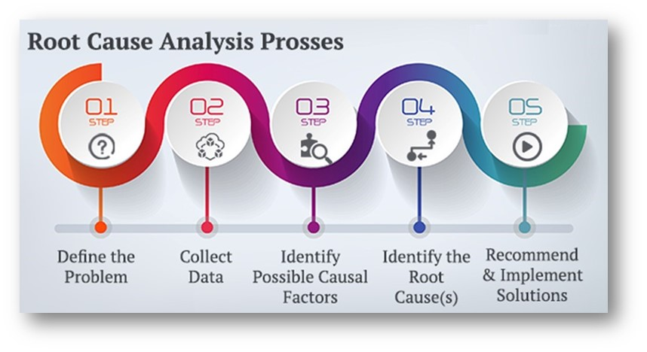When applying root cause analysis to a problem you should start with the five why’s. Most business problems can be broken down using the five why’s. Step guide for diagnosing a problem includes step one- identifying contributing factors (internal or external), step two- sorting factors, step three- classifying factors (correlated, contributing, unrelated, root cause), and step four- design for corrective action.

**Why RCA is Important**

Root cause analysis helps categorize and prioritize issues. Allowing you to take problems head-on and address them from the “root.” The four-step process includes defining the problem, determining the causal relationships, identifying effective solutions, and implementing and tracking solutions. RCA can be used to diagnose future job problems that your company may have. Using your knowledge of root cause analysis, you will be able to make a good impression on future bosses.

* **Six tips for performing a successful root cause analysis:**

1. Collect the right information- Making sure your data research is accurate, comprehensive, and consistent
2. Create a fear-free incident reporting environment- Allow others in the organization to report on the problem without fear. This is helpful because these are some of the people on the front line with the best knowledge of the problem.
3. Look beyond the incident report- Take a step back to look at the full scope of the problem, not just what is on the surface.
4. Ask questions- This part includes the five why’s. Explore all potential causes and begin to get to the why of the problem. Determine if this problem could happen again.
5. Focus your attention where you can have the greatest impact- Develop an action around the key issues. After you have fixed the root cause, access future incident rates to determine success of solution.
6. Leverage technology- Software can help simplify and streamline the process. Integrating technology can allow you to solve your root problems proficiently and efficiently.

**Real World Business Problem**

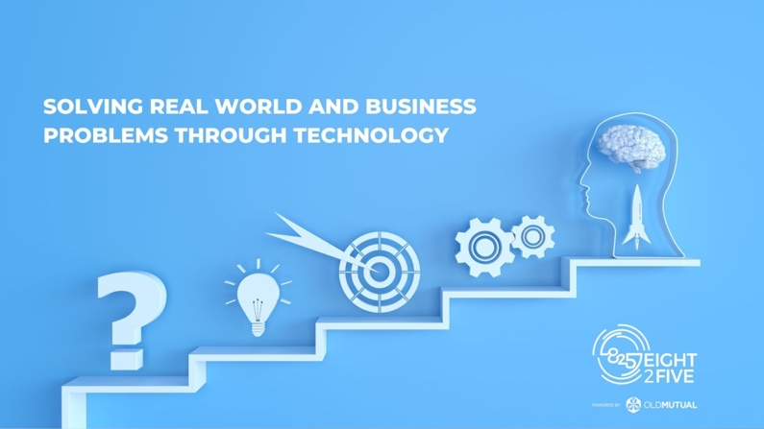I work in healthcare and insurance for the Office of Personnel Management. One of the tasks I have been assigned is to help with premium reconciliations. Premium reconciliations, also known as benefits reconciliation, are the process of matching insurance carrier data to enrollment data of the company. The problem occurs when the carrier's data does not match the company's data.

At OPM, making sure federal employees are paying their premiums on time is important because this is how the insurance carriers get paid. When people do not pay on time, the insurance carriers who provide the benefits will be upset with OPM. With thousands of employees signed up for benefits and many carriers, this process requires lots of manpower and time.

**Five Why’s**

Problem statement: Premium reconciliations are inaccurate and not done efficiently

* Why 1: A benefit has changed their information
* Why 2: OPM has not communicated the change to the carrier
* Why 3: There is no centralized process for collecting premiums
* Why 4: The carrier does not get the correct payment and complains to OPM
* Why 5: OPM is seen negatively by insurance carriers and other fellow insurance carriers.

There are so many moving parts in the current state. OPM is only able to see certain information due to HIPPA laws. During reconciliation, OPM is sent a document with a list of people as codes and needs to match this with the information the insurance companies have. The process is long where OPM works with many different carriers so communicating with all these carriers takes time. Matching all the codes to carrier data also takes time. When someone is not paying the amount, they need to or not at all. The carriers get frustrated as this is the way they make their money. When the carriers get frustrated, that is not a good thing for the company.

**Fishbone Diagram**

I did my fishbone diagram on some of the causes of the difficult reconciliation process. There are many moving parts in the diagram including data, process, postal service health benefits customer service center, OPM retirement services, policies, and IT department data collection/warehouse. There are so many moving parts which is part of the reason the reconciliation process is not easy now.

* The National Finance Center handles OPM’s direct pay remittance system. This is another company that OPM has to be in contact with in order to make sure people are paying on time.
* The many different divisions of OPM also must come together including retirement services, service center, and the IT department. All these departments have different jobs for the reconciliation process, so the process is not streamlined and long.
* There are also many policies and processes dealing with the benefits of reconciliation. These policies aim to make sure all the rules and procedures for premium reconciliation are met properly.

**Major Influences Driving the Problem**

The process of reconciliation for OPM is not streamlined and centralized. With so many moving parts like NFC and the multitude of departments involved such as enrollment services, retirement services and IT, there are bound to be some missteps. Mid cycle changes and qualifying life events can cause difficulties as they change the employee's premium plan. Keeping up with the changes and communicating with carriers can be difficult with limited information.

**Corrective Action Plan**

In my opinion, the best way to correct this problem is to create a centralized, streamlined system with OPM in the middle. Create a system that notifies daily of any changes made by employees to their benefits, that automatically communicates to carriers. Each carrier will have access to this database where they can see changes made by the people they provide. Next, with both OPM and the carriers having access to the same communication, one or both parties will communicate and sign off if they have seen the change. Finally, any billing changes will be mailed out by OPM themselves.

* Create a streamlined system that can identify one-to-one matches, and train employees on how to use them. Having a system like this will make the reconciliation process easier as one document will have all the information.

**Measuring Success**

A good way to measure success for this action plan will be a survey. OPM can send a survey out to all the carriers inquiring about the performance of the new system. General feedback will also help to adjust the system. Premium reconciliations are also quantifiable because someone either pays or they don’t. So, when we receive payment, we will be able to keep track of the amount of correct premium reconciliations. Over ninety. five percent correct, and paid reconciliations is a good mark for the company.